peepl
know before you go.
PARTNER BRIEFING DOCUMENT
Product Status · Market Opportunity · Revenue Projections · Build Confidence

Prepared: March 2026
CONFIDENTIAL — For Partner Review Only

The Product — 10 Core Screens
Peepl has been fully designed across 62 screens. The 10 screens below represent the primary consumer and merchant flows — from sign-in through the live feed, crowd reporting, gamification, deals discovery, and the self-serve merchant advertising portal.

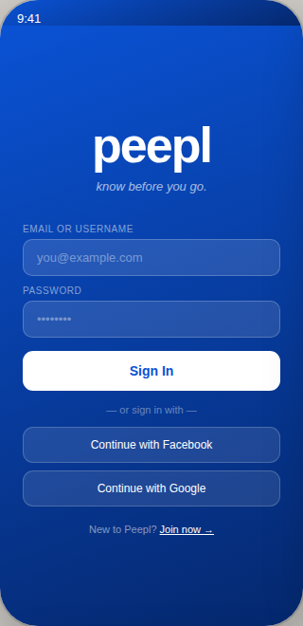  Sign In | 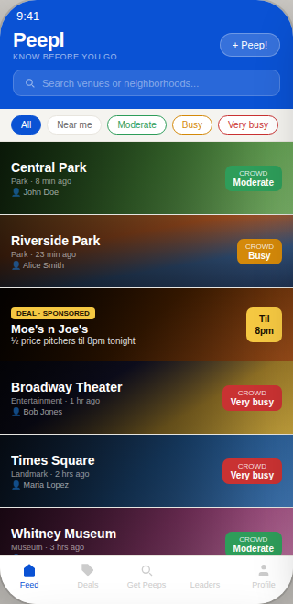  Main Feed | 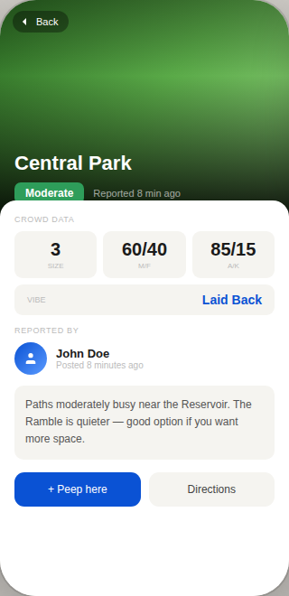  Post Detail | 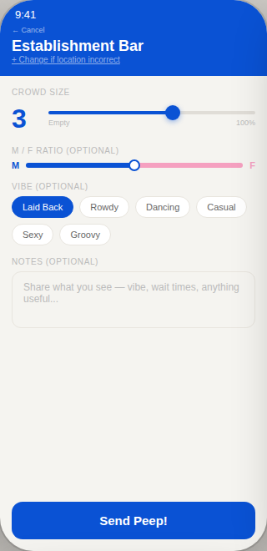  Peep Creation | 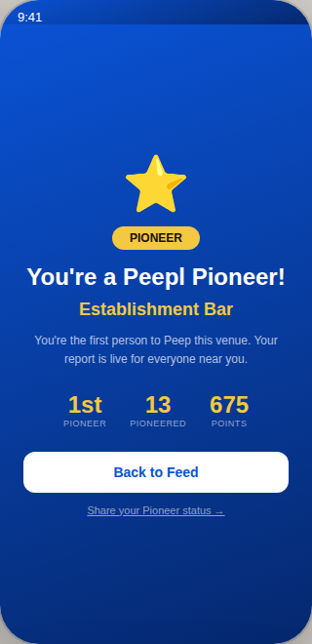  Pioneer Congrats
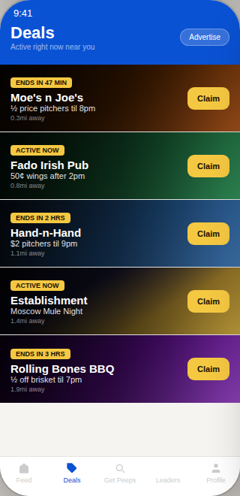  Deals Page | 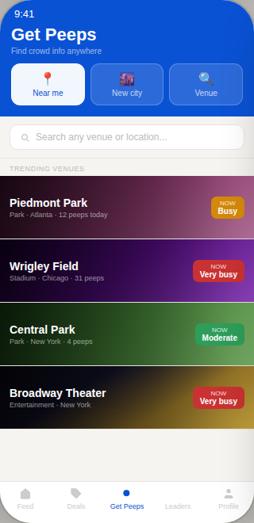  Get Peeps | 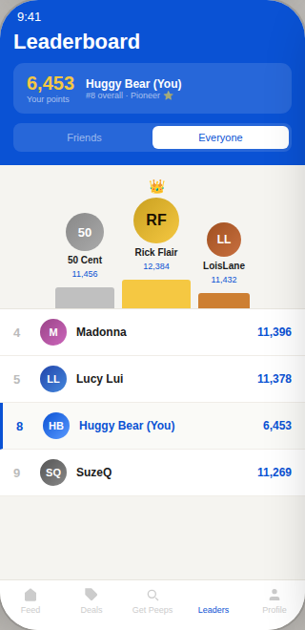  Leaderboard | 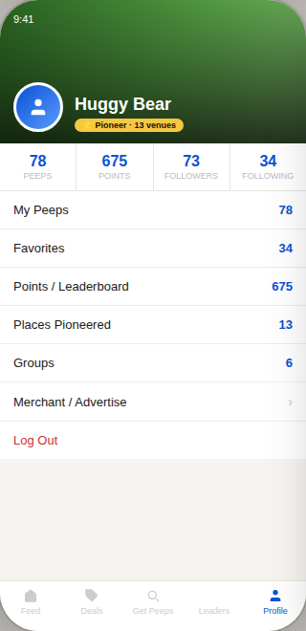  Profile | 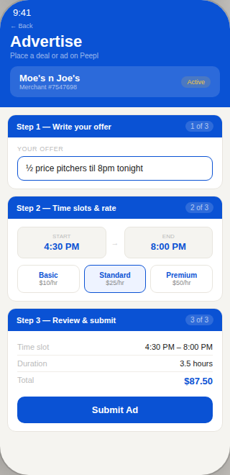  Merchant Portal

These are not wireframes. This is the production visual specification — every screen designed, every state covered, every flow connected.

Executive Summary

Peepl is a real-time crowd intelligence platform that answers the single most common question people ask before going anywhere: what is it like right now? Users post crowd reports — size, male/female ratio, adult/kid ratio, vibe, age range — from venues they are physically standing in. The result is a living, breathing dataset of what is actually happening at bars, restaurants, parks, theaters, and thousands of other venues at this exact moment.

The product concept was fully designed and 85% built between 2015 and 2016, with a complete 73-screen UI specification, a functional self-serve merchant advertising portal, and a gamification system that drives organic user engagement. Development was halted by a single developer's disappearance. The vision, the design, and the business model survived intact.

In 2025, a new technical foundation was built — Node.js backend, Firebase, Socket.io, geofencing services, and a React Native mobile client. The infrastructure is solid. The product specification is complete at 62 screens. What remains is connecting the two and building to the full feature set defined by the original design.

The question is not whether Peepl can be built. It can — and it will be built properly, with every screen specified, every flow designed, and a systematic development approach that eliminates the single-developer dependency risk that stopped the original.

62  Screens Designed  Complete UI specification | 10+  Years of Refinement  Original concept: 2015 | 7  Revenue Streams  At full scale

Where Peepl Is Today

The Original Vision (2015–2016)
Peepl was conceived in 2015 as a crowd-sourced, real-time venue intelligence platform — years before any competitor attempted to solve this problem at the product depth Peepl envisioned. The original build reached 85% completion with a fully designed 73-screen UI specification, a working self-serve merchant advertising portal, geofencing-triggered push notifications, a gamification system with Pioneer status and leaderboards, and a multi-dimensional crowd data model that captured far more signal than any competing product. Development was stopped when the sole developer disappeared.

The 2025 Technical Foundation
A new backend and mobile client were built in 2025, establishing the technical infrastructure for the rebuilt product:

- Backend: Node.js / Express with Firebase Admin, Socket.io for real-time, and a geofencing service that automatically detects when users enter venues
- Database: Firebase Firestore with correct composite indexes defined for all query patterns
- Mobile: React Native / TypeScript with proper navigation architecture, AsyncStorage, and push notification infrastructure
- Security: Helmet, compression, express-rate-limit, express-validator, JWT authentication, bcrypt password hashing
- Infrastructure: Docker, docker-compose, GitHub Actions CI/CD pipeline with test and lint gates
- Services: NotificationService, GeofencingService, LocationService, SocketService — all scaffolded and partially functional

What Needs to Be Built
Critical Bug Fixes  - AuthService export/signature mismatch — login broken  - Firestore security rule blocks all peep creation  - Dual auth system — Firebase Auth and JWT disconnected  - Hashed passwords stored unnecessarily in Firestore  - GET /venues/nearby uses body validators incorrectly  - API calls commented out in mobile screens  - Routes registered after server.listen() | Missing Features  - Full rich Peep creation (crowd size, M/F, A/K, vibe, age)  - Venue page with aggregated peep history  - Deals page with merchant deals  - Pioneer system and gamification engine  - Leaderboard and points system  - Self-serve merchant advertising portal  - GetPeeps search (3 modes)  - Groups, share, invite systems  - VIPeeps subscription tier  - Map screen with live heat map

The Product

Core User Experience
Peepl operates on a simple and powerful loop. A user walks into a venue. Their phone detects their location via geofencing and sends a push notification: "You're at Establishment Bar — want to Peep it?" The user taps through, posts a 10-second crowd report, and earns points. Every other Peepl user who has favorited that venue, or who opens the app looking for somewhere to go, immediately sees fresh, human-sourced intelligence about that location.

Crowd Size 1–5 · Male/Female Ratio · Adults/Kids Ratio · Age Range · Vibe Tags · Notes · Photo/Video · Crowd Trend
No competitor captures this level of crowd intelligence. This is the data moat.

Gamification — The Retention Engine
The Pioneer system is Peepl's most powerful retention mechanic. The first user to post a crowd report at any venue earns permanent Pioneer status for that location. Their name appears on the venue page forever. They earn bonus points. When subsequent users post, the Pioneer receives notifications — closing a feedback loop that brings users back without any marketing spend. The leaderboard creates friendly competition. These mechanics are identical to what drove Waze's organic growth — social accountability for contributing to a shared utility.

Market Position & Competitive Advantage

The Problem Nobody Has Solved
"Is it worth going there right now?" is the most common question people ask before going out. It is not answered by Yelp (historical reviews), Google (passive foot traffic histogram with no community), Waze (acquired and limited to driving), or any social network. The real-time, human-sourced, multi-dimensional crowd intelligence Peepl provides does not exist anywhere at this product depth.

The Self-Serve Merchant Moat
The merchant advertising portal is Peepl's structural competitive advantage. A merchant logs in, writes an offer, picks a time slot, selects a rate, and goes live. No sales team. No minimum spend. No agency relationship. This is the Airbnb model applied to local advertising — infinitely scalable, globally deployable, and revenue-generating from day one.

The Key Advertising Insight
Most apps serve ads to passive browsers. Peepl users are in active go/no-go decision mode — right now, tonight, in the next hour. That is the same high-intent window that made Google search advertising the most valuable ad format ever created. Peepl owns that window for local, physical venues.

Revenue & Valuation Projections

Peepl operates seven distinct revenue streams. Each scales independently with user growth. The projections below are conservative — execution against a product this differentiated could materially exceed these numbers.

1 Million MAU — City Launch Phase
Revenue Stream | Conservative | Optimistic
Programmatic native advertising | $2.2M | $3.6M
Self-serve merchant ads (2,000 accounts) | $9.6M | $14.4M
VIPeeps subscription (3% conversion) | $1.8M | $3.0M
Travel intent premium inventory | $1.4M | $2.8M
B2B data licensing | $0.5M | $1.2M
Events & partnerships | $0.2M | $0.5M
TOTAL ANNUAL REVENUE | $15.7M | $25.5M

$15.7M  Conservative Revenue  Annual at 1M MAU | $25.5M  Optimistic Revenue  Annual at 1M MAU | $188M–$382M  Implied Valuation  At 12–15x revenue

10 Million MAU — Multi-Market Expansion
Revenue Stream | Conservative | Optimistic
Programmatic native advertising | $27.5M | $44M
Self-serve merchant ads (12,000 accounts) | $57.6M | $86.4M
VIPeeps subscription (4% conversion) | $24.0M | $40.0M
Travel intent premium inventory | $28.0M | $44.0M
B2B data licensing | $8.5M | $18.0M
Events & partnerships | $3.5M | $7.0M
International licensing | $4.0M | $9.0M
TOTAL ANNUAL REVENUE | $153.1M | $248.4M

$153M  Conservative Revenue  Annual at 10M MAU | $248M  Optimistic Revenue  Annual at 10M MAU | $1.8B–$3.7B  Implied Valuation  At 12–15x revenue

50 Million MAU — Global Platform
Revenue Stream | Conservative | Optimistic
Programmatic native advertising | $112M | $180M
Self-serve merchant ads (50,000 accounts) | $300M | $480M
VIPeeps subscription (4% conversion) | $120M | $200M
Travel intent premium inventory | $140M | $220M
B2B data licensing | $60M | $120M
Events & partnerships | $17.5M | $40M
International licensing | $15M | $35M
TOTAL ANNUAL REVENUE | $764.5M | $1.275B

$765M  Conservative Revenue  Annual at 50M MAU | $1.275B  Optimistic Revenue  Annual at 50M MAU | $9.2B–$19.1B  Implied Valuation  At 12–15x revenue

100 Million MAU — Acquisition Target / Exit
Revenue Stream | Conservative | Optimistic
Programmatic native advertising | $275M | $400M
Self-serve merchant ads (100,000+ accounts) | $600M | $960M
VIPeeps subscription (5% conversion) | $300M | $480M
Travel intent premium inventory | $259M | $380M
B2B crowd intelligence data | $104M | $200M
Events & venue partnerships | $35M | $80M
International licensing | $30M | $60M
TOTAL ANNUAL REVENUE | $1.603B | $2.56B

$1.60B  Conservative Revenue  Annual at 100M MAU | $2.56B  Optimistic Revenue  Annual at 100M MAU | $19.2B–$38.4B  Implied Valuation  At 12–15x revenue

Valuation Summary — All MAU Milestones
Scale | Annual Revenue Range | Multiple | Valuation Range
1M MAU | $15.7M – $25.5M | 12–15x | $188M – $382M
10M MAU | $153M – $248M | 12–15x | $1.84B – $3.72B
50M MAU | $765M – $1.275B | 12–15x | $9.18B – $19.1B
100M MAU — Exit Target | $1.60B – $2.56B | 12–15x | $19.2B – $38.4B

Strategic Acquisition Premium
These valuations use standard 12–15x revenue multiples for platform businesses with diversified revenue, subscription components, and proprietary data. Strategic acquisitions — where multiple buyers compete — consistently exceed these multiples. WhatsApp was acquired for $19 billion with no revenue. Waze was acquired for $1.65 billion with no merchant revenue. Peepl at 100M MAU with $1.6B in real, diversified revenue, a proprietary global crowd intelligence dataset, and a self-serve merchant marketplace presents a substantially stronger acquisition case than either precedent. The likely strategic buyers — Google, Meta, Apple, Booking Holdings — all have structural gaps that Peepl fills.

Build Confidence — This Will Be Built Properly

This section directly addresses the most important question a partner can ask: can this actually be built, and will it work as specified? The answer is unequivocally yes — and the evidence for that confidence is structural, not aspirational.

The single greatest risk to the original Peepl was dependency on one developer who disappeared at 85% completion.
That risk no longer exists. The development model for Peepl 2025 eliminates it structurally.

Why the AI-Assisted Development Model Changes Everything
Peepl is being built using Claude — Anthropic's most capable AI system — as the primary development partner, augmented by Cursor (an AI-native code editor) and targeted human developers for specific, bounded scopes. This approach directly addresses every failure mode that stopped the original build.

What AI Development Provides  - Code review on every file — bugs caught before they ship  - Architecture decisions made with full codebase context  - No single developer dependency — any qualified developer can pick up where work stops  - Complete documentation of every decision  - UI specification translated directly to working code  - Security vulnerabilities identified and corrected systematically | What Has Already Been Done  - Complete 62-screen UI specification — designed, rendered, reviewed  - Full technical audit of the 2025 codebase — every bug identified  - 60-item prioritized task list with phase sequencing  - Revenue model built across 4 MAU milestones  - Merchant portal flow fully designed  - Database schema and index strategy validated

The Technical Assessment Is Honest
A thorough review of the existing 2025 codebase identified 5 critical bugs, 4 security issues, and 3 architectural problems. Every one of them has been documented, diagnosed, and has a clear fix. This is not a codebase that needs to be rebuilt — it is a codebase that needs to be corrected and completed. The critical bugs include a non-functional login, a Firestore rule that blocks peep creation, and a dual authentication system running two parallel systems without connecting them. These are implementation errors with straightforward corrections, not architectural flaws.

The 60-Item Build Plan
Phase | Focus | Items | Timeline | Exit Criteria
Phase 1 | Critical Bug Fixes | 14 items | Weeks 1–2 | App is functional
Phase 2 | Missing Screen Builds | 13 items | Weeks 3–6 | Full consumer feature set
Phase 3 | Merchant Portal Build | 8 items | Weeks 7–9 | Revenue infrastructure live
Phase 4 | Backend Feature Completion | 13 items | Weeks 10–14 | All backend features complete
Phase 5 | Infrastructure & Launch Prep | 12 items | Weeks 15–18 | App store submission ready

The UI Specification Is Production-Ready
The 62-screen specification produced for Peepl 2025 is not a mood board or a concept deck. It is a fully rendered, interactive prototype in the production visual language — every screen, every state, every edge case, from splash screen through the complete merchant portal. A developer opening this specification on day one has everything they need. There is no ambiguity about what needs to be built. This is what prevented the original build from surviving its developer's disappearance — no specification robust enough to be handed off. That problem is solved.

The Definitive Statement on Build Viability
Peepl will be built correctly. The specification is complete. The bugs are known and fixable. The architecture is sound. The development approach eliminates single-point-of-failure risk. The revenue model is validated. The market has waited ten years for this product and has not been served by any competitor in the interim.

The 2025 version of Peepl is not starting over. It is finishing what was 85% complete a decade ago, with better tooling, a more mature market, a complete design specification, and a systematic approach to development that means no single person's failure can stop it again.

The product will work. The revenue will follow. The exit opportunity is real.

A Business Designed to Pay for Itself

Most apps follow the same model: build, burn cash, hope to monetize later. Peepl was deliberately designed to invert that. The self-serve merchant portal means the first dollar of revenue can arrive before Peepl has a single thousand users — because merchants are not paying for scale. They are paying for placement in a specific time window, near their specific location, reaching people who are actively deciding where to go right now.

A bar owner in Atlanta does not need Peepl to have 50,000 users in Atlanta. They need Peepl to have users within half a mile of their bar on a Friday night. That distinction changes the unit economics of the entire business — and it means the product was architected to be financially self-sustaining from the first merchant who signs up.

Operating Cost Coverage at Every Stage
The primary ongoing costs of running Peepl are infrastructure: Firebase hosting, Firestore reads and writes, push notification delivery, image storage, and compute. These scale with users — but so does merchant revenue, and merchant revenue scales faster.

Stage | Est. Monthly Infra Cost | Merchant Revenue Source | Est. Monthly Revenue | Coverage Ratio
Launch (under 50K MAU) | $500–$1,500/mo | 20 merchant accounts @ $150/mo avg | $3,000/mo | 2–6x covered
Early growth (50K–250K MAU) | $1,500–$4,000/mo | 100 accounts @ $200/mo avg | $20,000/mo | 5–13x covered
Mid scale (250K–1M MAU) | $4,000–$12,000/mo | 500 accounts @ $300/mo avg | $150,000/mo | 12–37x covered
1M+ MAU | $12,000+/mo | Programmatic + merchants | $1.3M+/mo | 100x+ covered

Firebase's free tier handles approximately 50,000 MAU before meaningful billing begins. Even 20 merchant accounts running two ad slots per week at the Basic rate of $10/hr for three hours generates $2,400 per month — covering cloud costs with room to spare before the app reaches 10,000 users. The merchant portal is not just the revenue engine. It is the financial life support system that means Peepl never needs to raise capital to keep the lights on.

The Low-Barrier Merchant Entry Point
The pricing architecture was deliberately designed to remove every objection a local merchant might have. A bar owner does not need to commit to a monthly budget, sign a contract, or work with an agency. They log in, write their offer, choose a time slot, select Basic at $10/hr, and go live. The minimum experiment is a $10 ad running for one hour on a Tuesday night.

That is a $10 bet, not a $3,000 commitment. At that price point, merchants say yes to try it. When they see people walking in citing the Peepl deal, they come back and spend more. The self-serve model creates a flywheel: low barrier to entry drives adoption, ROI evidence drives retention and upsell, merchant density makes the deals page more valuable to users, user engagement justifies higher ad rates. Each part of the loop strengthens the next.

Basic: $10/hr · Standard: $25/hr · Premium: $50/hr · Minimum: 1 hour · No contracts · No minimums · Live instantly
The lowest-friction local advertising product ever built. A merchant can be live in under five minutes.

Three Revenue Streams Before Critical Mass
Most platforms need millions of users before any revenue stream becomes meaningful. Peepl has three revenue streams that activate well before critical mass:

- Self-serve merchant ads — active from the first merchant signup, day one of launch in any city
- Native feed deals — the deal cards injected into the consumer feed are the highest-performing format and require no additional infrastructure beyond what already exists
- VIPeeps subscriptions — even a modest conversion of early power users at $4.99/month generates recurring revenue with zero marginal cost

Programmatic advertising — the fourth and eventually largest revenue stream — requires scale, but it activates naturally as user density grows. By the time programmatic becomes meaningful, the first three streams have already established financial self-sufficiency. There is no moment in Peepl's growth curve where the business is dependent on a single revenue source or where infrastructure costs outpace revenue.

What This Means for the Partnership
The self-funding architecture has two implications that matter directly to any partner conversation.

First, it means the partnership is not a race against a burn rate. There is no countdown clock forcing premature scaling decisions or desperate fundraising. The product can be built correctly, launched carefully, and grown deliberately — because the merchant revenue model covers operating costs from the beginning. Patience is not a luxury here. It is a structural advantage built into the business model.

Second, it means that if the partners choose to raise external capital at any point, every dollar raised goes into growth — not survival. Marketing, merchant acquisition, city launches, hiring — not AWS bills and Firebase overages. That is a fundamentally different and more powerful use of investment capital than what most startups can offer.

Peepl was designed to be owned, not funded. The merchant revenue model is the reason that is possible.

Path Forward

Launch Sequencing
Stage | Description | Timeline | Milestones
Market 1 | Single US city — density first | Month 1–6 | Pioneer recruitment, 20+ merchant deals seeded
Markets 2–5 | Additional US cities | Month 7–18 | Apply launch playbook, programmatic goes live
International 1 | First international market | Month 12–24 | English-speaking market, same playbook
Global | 20+ countries active | Year 2–3 | Merchant self-serve scales globally, B2B data launches
Exit Window | 100M MAU target | Year 5–8 | Competitive acquisition process initiated

The Exit Strategy
The intended outcome is acquisition at or before 100M MAU. The acquirer pool — Google, Meta, Apple, Booking Holdings — all have strategic rationales for acquiring Peepl that are independent of each other. A competitive process is the goal. With no VC dilution and no investors with liquidation preferences, the ownership stake at exit is substantially higher than any venture-backed comparable. The difference between owning 20% of a $20B exit and owning 80% of a $20B exit is $12 billion. Peepl is being built to be owned, not managed.

Summary
Peepl is a fully specified, partially built, defensibly positioned real-time crowd intelligence platform with a proven business model, a 10-year refined product vision, a complete 62-screen design specification, a systematic build plan, and an exit opportunity in the $19B–$38B range at 100M MAU.
The product can be built. The revenue is real. The market is waiting. The development approach eliminates the risk that stopped the original. The only variable is execution — and execution is what this partnership is for.
Know before you go.

CONFIDENTIAL — For Partner Review Only
Peepl · peepl.app · March 2026

